# Grasshopper Resurvey: Phenological responses to climate change (Answer Key)

## [Link to the visualization](https://huckley.shinyapps.io/grasshoppers/)

## [Link to TrEnCh-Ed](https://trench-ed.github.io/#)

## Objectives

* Understand how temperature influences insect development rate.
* Use this understanding to examine shifts in seasonal timing (phenology) in response to cool and warm seasons.

## Cross-cutting concepts -- *Next Generation Science Standards*

* Patterns
* Cause and effect
* Scale, proportion, and quantity
* Stability and change

## Cross-cutting concepts -- *Other*

* Change vs variability
* Data reasoning

## Standards

Life Science Standards (LS)

|  |  |
| --- | --- |
| HS-LS2-6 | Evaluate claims, evidence, and reasoning that the complex interactions in ecosystems maintain relatively consistent numbers and types of organisms in stable conditions, but changing conditions may result in a new ecosystem. |

*Advanced Placement Environmental Science*

|  |  |
| --- | --- |
| 2.6 - Describe how organisms adapt to their environment. | * **ERT-2.H.1-** Organisms adapt to their environment over time, both in short- and long-term scales, via incremental changes at the genetic level. * **ERT-2.H.2** - Environmental changes, either sudden or gradual, may threaten a species’ survival, requiring individuals to alter behaviors, move, or perish. |

## Instructions

First, read through the Grasshopper Resurvey introduction in the visualization. This will give you the required background information for these questions.

### Background

1. Define phenology.

The timing of important life events such as when birds migrate or when plants flower.

1. What is diapause?

A state of dormancy that is marked by the decrease in metabolic rates, typically in climatically adverse environments.

1. What organism in this reading spent months in diapause?

Montane grasshoppers

#### Colorado Grasshoppers: Then and Now

1. Define elevational transect.

A series of survey sites located at different elevations.

1. Extra question: Summarize Nufio’s journey to science.

He began his undergraduate career in art. After surveying the patterns in nature, he fell into a passion for science. A marine invertebrate class was full and thus he opted into an entomology class. This pointed him to his future in insect science.

#### Grasshopper traits

1. Which species are early season species?

*Aeropedellus clavatus* and *Melanoplus boulderensis.*

1. Which species are late season species?

*Camnula pellucida, Chloealtis abdominalis, Melanoplus dawsoni,* and *Melanoplus sanguinipes.*

#### This visualization

1. What is a growing degree day (GDD)?

It is a unit of heat accumulation that adds up the number of degrees by which temperatures exceed the threshold temperature.

1. How are GDDs different from season GDDs?

Season GDDs are the accumulation of GDDs over the course of a season. Organisms need to reach a certain season GDD to develop into adulthood.

### Analysis

#### Part A: Exploring Development Index Data

In this first exercise, you can generate figures that all have the same general structure. On the y-axis, you’ll see values for the development index. On the x-axis, you can select between Season GDDs or Day of Year (in Day of Year units, Jan 1=1, and Dec 31=365). Finally, you can select one or more grasshopper species and one or more sites (elevations) to plot. The resulting lines will be in the shape of an upward trajectory that eventually levels off. Each line represents one population of grasshoppers (one species living at a particular elevation in a particular year). The line slopes upwards because the population as a whole matures over the course of the season, so its development index increases. Finally, when all individuals are adults, the line levels out. Dashed lines represent historical data and solid lines represent resurvey data, while bluer colors indicate cooler years and redder colors indicate warmer years.

1. For this question, look at all of the species plots
   1. What is each graph showing?

Each graph is showing the development index of a species of grasshoppers over a season at different elevation levels.

* 1. In general, how does phenology differ between cool and warm years?

Generally, warmer years allow the population to begin development earlier in the year and reach maturity earlier.

* 1. How does phenology differ between low and high elevations?

The grasshoppers at higher elevations begin to develop later in the season.

1. Select the *Aeropedellus clavatus* to plot.
   1. How does phenology differ between historic and resurvey years for *A. clavatus*? (Hint: Change the “variable for columns” to Year and select some historic years and some resurvey years. The closer a line is to the left of the panel, the earlier in the season development begins, and vice versa.)

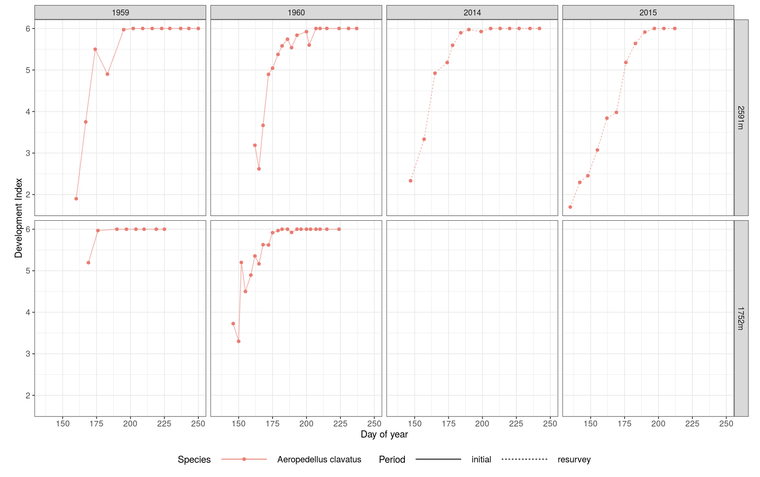

*Aeropedellus clavatus* begins to develop (exit its diapause) earlier in the season in the resurvey years compared to the historic years.

* 1. Why might this be?

A potential cause of this earlier start is that the grasshoppers are adapting to the warmer climate and emerging earlier to match the phenology of the plants they feed on.

1. Next, select just the *Melanoplus sanguinipes*.
   1. How does phenology differ between high- and low-elevation populations of *M. sanguinipes*? (Hint: The steeper the line, the faster development occurs.)

While most populations at the different elevation levels are beginning to develop (exiting their diapause) earlier in the season, this phenological shift is particularly pronounced for the highest elevation species.

* 1. Why might this be?

A potential cause of this slower development is that, while there are GDDs earlier in the year, they are for short periods of time during the day and thus the grasshoppers develop slower. This can be compared to high-elevation populations which are limited in emergence by the melting of the snow, and their emergence and growth begin when the growing temperature is maintained for longer periods of the day.

1. For this question, just look at the time periods of 2007 and 2010.  
   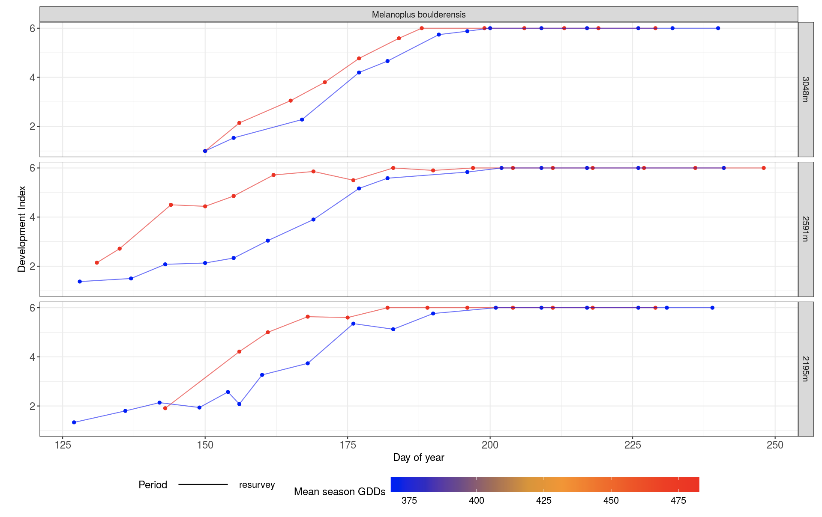

2007 = red; 2010 = blue

* 1. How does phenology for *M. boulderensis* differ in 2010 vs. 2007?

The 2007 populations reached full development (development index of 6) earlier in the year than the 2010 populations.

* 1. What about *M. dawsoni*?  
     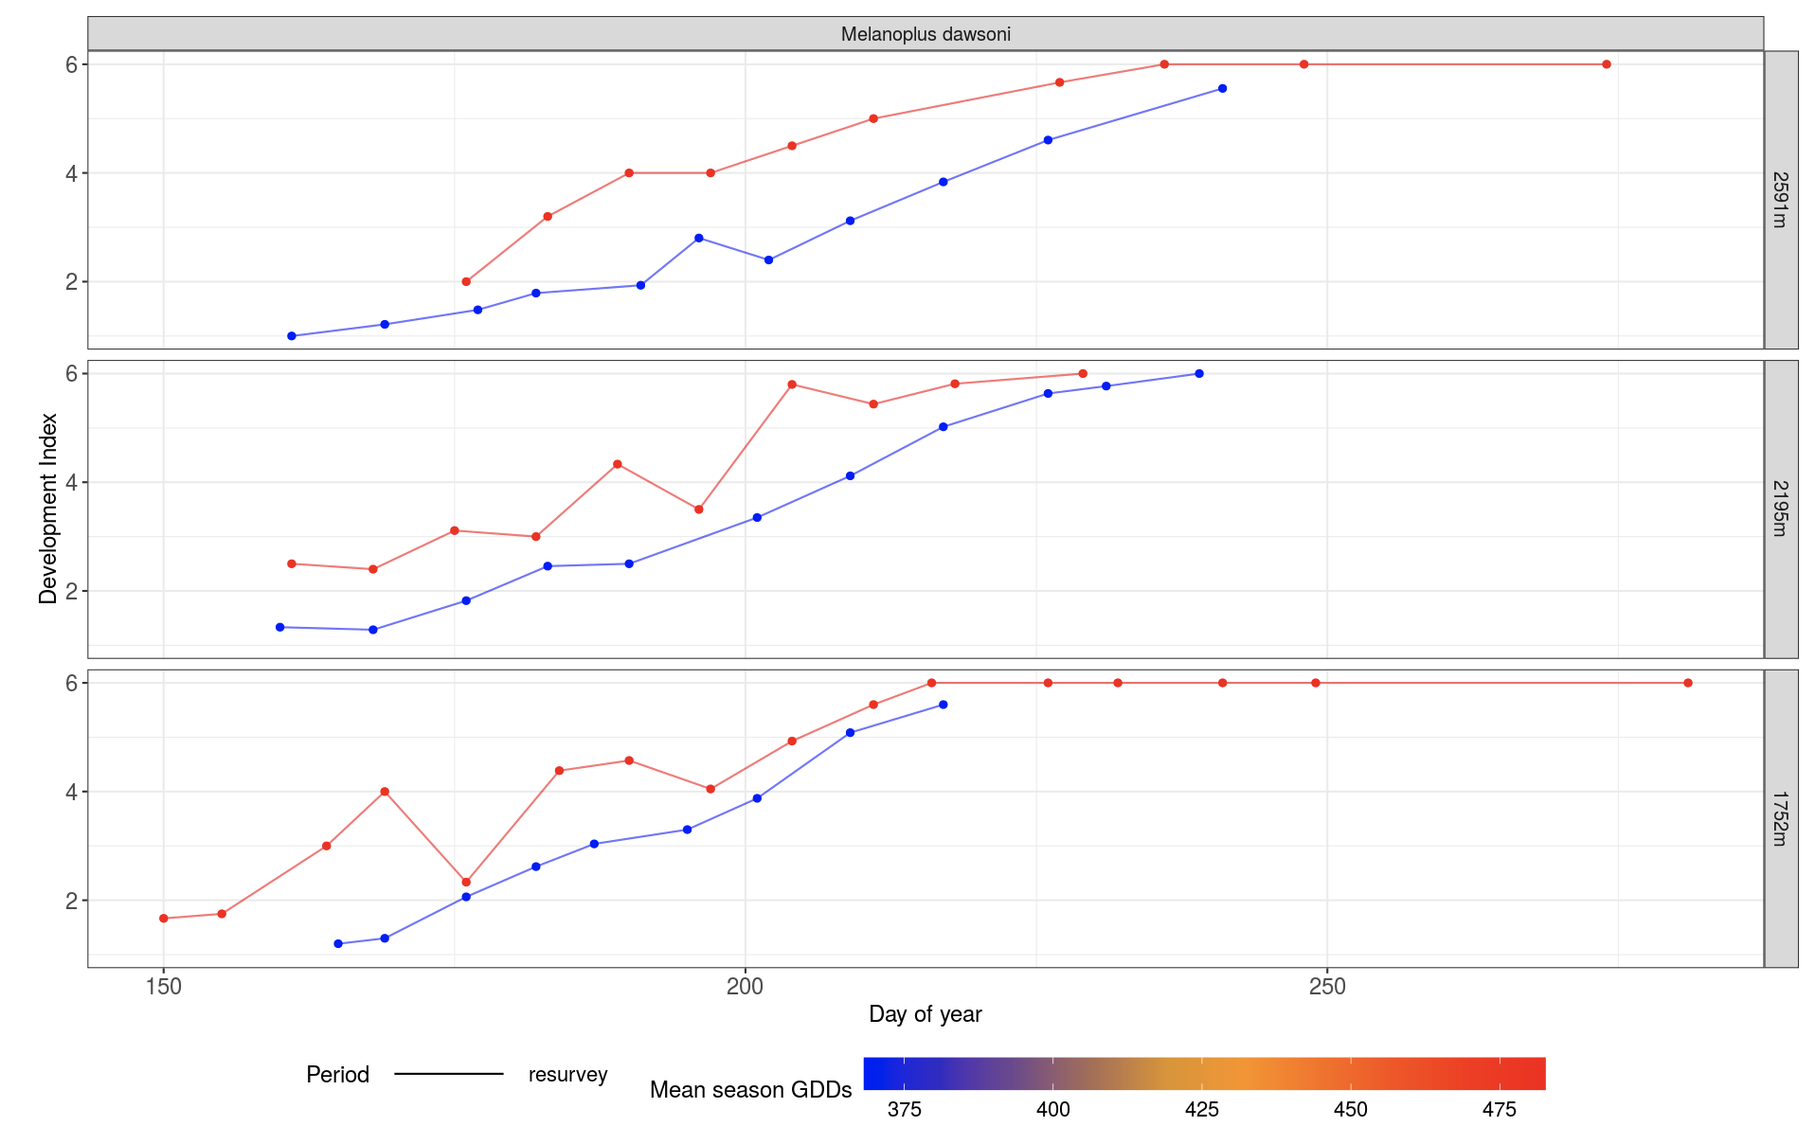

2007 = red; 2010 = blue

Likewise, the 2007 populations reached full development (development index of 6) earlier in the year than the 2010 populations.

* 1. Why might this be?

This may be due to 2007 having a higher mean season GDDs than 2010.

#### 

#### Part B: Exploring relationships between time, growing degree days, and grasshopper phenology

In the second exercise, you can again select one or more grasshopper species and one or more sites (elevations) to plot. Two kinds of figures will be generated: On the left, you’ll see data showing which day of the year your chosen population reached adulthood in relation to how warm the growing season was that year. For example, a data point located at 200 on the x-axis and 180 on the y-axis reflects a population that reached adulthood on day 180 in a year when the summer season had 200 growing degree days.

On the right, you’ll see data showing how much accumulated heat your chosen population had experienced before reaching adulthood, again in relation to how warm the growing season was that year. For example, a data point located at 300 on the x-axis and 200 on the y-axis reflects a population that reached adulthood after it had experienced 200 growing degree days, in a year when the summer season had 300 growing degree days. A relatively horizontal line suggests that the population tended to reach adulthood after experiencing the same amount of accumulated heat, no matter how warm or cool the season was.

1. Plot the data for all species at site 2591m.

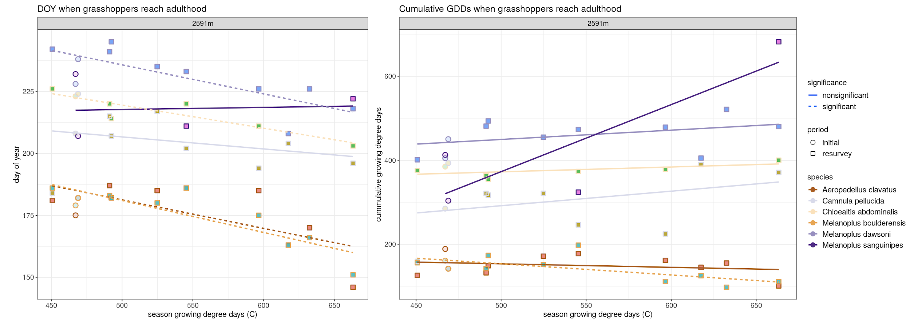

* 1. In cool vs. warm years, do the dates at which grasshoppers reach adulthood change?

In warmer years, most species reach adulthood earlier.

* 1. Does the amount of accumulated heat they experience change before reaching adulthood?

For some species, the amount of accumulated heat they experience increases. For others, the amount of accumulated heat they experience decreases.

* 1. Is this different for early vs. late-season grasshoppers (see the **Grasshopper traits** table in the reading above)?

Yes, early-season grasshoppers require less GDD and reach adulthood earlier in the season than late-season grasshoppers.

1. Plot the data for the species *Melanoplus boulderensis*.

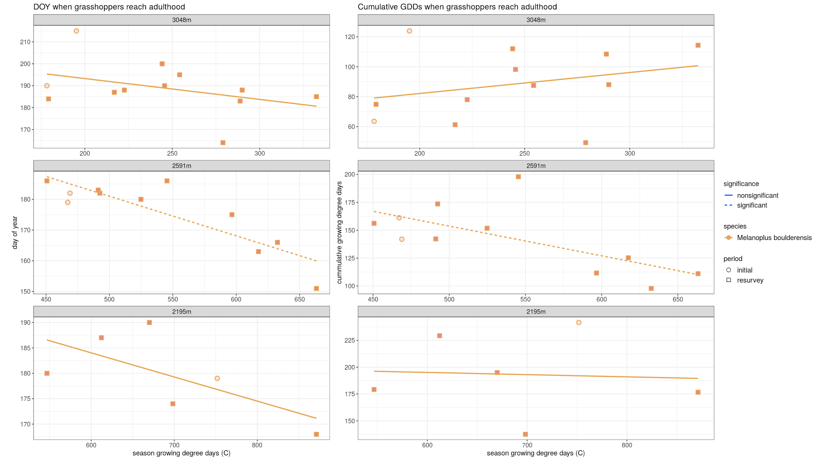

* 1. How does the date at which *M. boulderensis* reaches adulthood change with seasonal warmth?

Generally, the date at which it reaches adulthood decreases with seasonal warmth.

* 1. Is this different at low vs. high elevations? Explain why this might be.

This is much more pronounced at high elevations.

1. Plot the data for the species *Chloealtis abdominalis.*

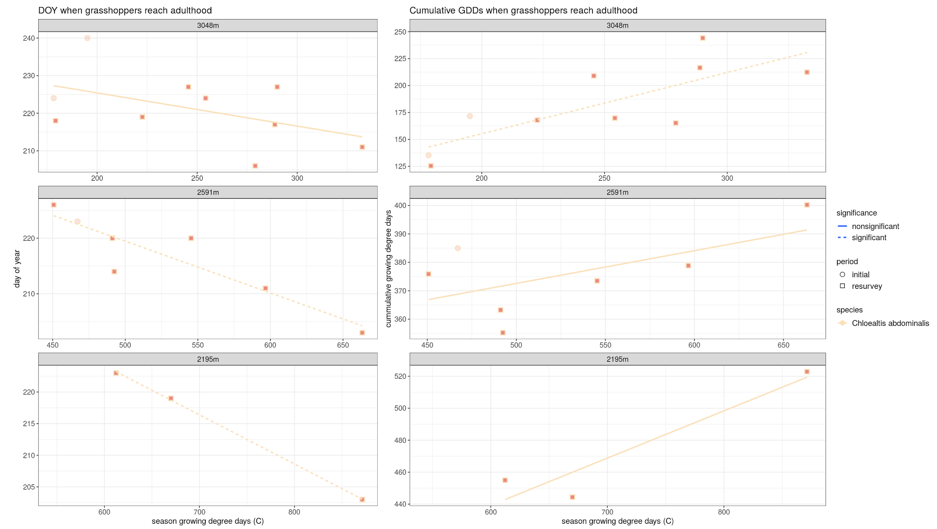

* 1. How does the amount of accumulated heat experienced by *C. abdominalis* when it reaches adulthood change with seasonal warmth?

The amount of accumulated heat it experiences increases with seasonal warmth.

* 1. Is this different at low vs. high elevations? Explain why this might be.

For this species, it seems that this is more pronounced at lower elevations. This might be due to a general abundance of GDDs at a lower elevation. Therefore, low-elevation grasshoppers may not follow warmer temperatures as closely as the more at risk high-elevation populations.

4. Is phenology different for early vs. late-season grasshoppers?

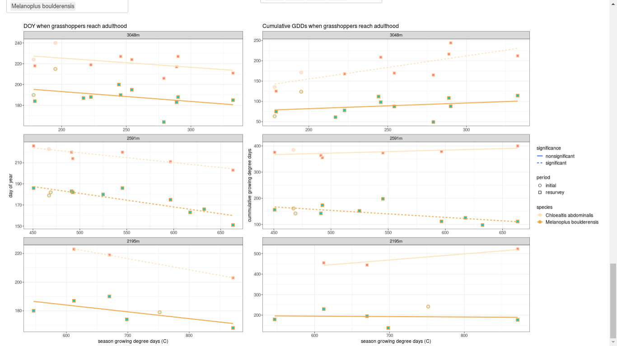

Early-season grasshoppers have less accumulated GDDs than late-season grasshoppers. Early-season grasshoppers also have an earlier DOY than late-season grasshoppers.